**CHAPTER 3**

**PROPOSED WORK**

**3.1 Dataset Gathering**

To train the system, a dataset is required comprising of testing and training data. The dataset used in this project is self-generated. The testing dataset comprises of 6 sets of 1000 images each in which each set denotes a different gesture. The training data comprises of 6 sets of 100 images each in which each set denotes a different gesture. For capturing the data, the camera clicks the image in a loop depending on which type of image it is. Every image gets automatically numbered based on the iteration value.

The hand images are identified by background elimination technique. First a still background is chosen. And after a few frames, any movement on the screen is considered as the foreground images. The largest foreground image contour is considered as the main hand image so that any small movement does not create any external noise. The hand contour is converted to white colour and the entire background is made black in colour.

 Figure 3.1.1 Background eliminated image

Once the image is converted to the required format, a keypress begins the recording of the images. One image is recorded in every iteration. Once the required number of images is reached, the loop automatically ends storing every image captured in the hard drive of the local machine.

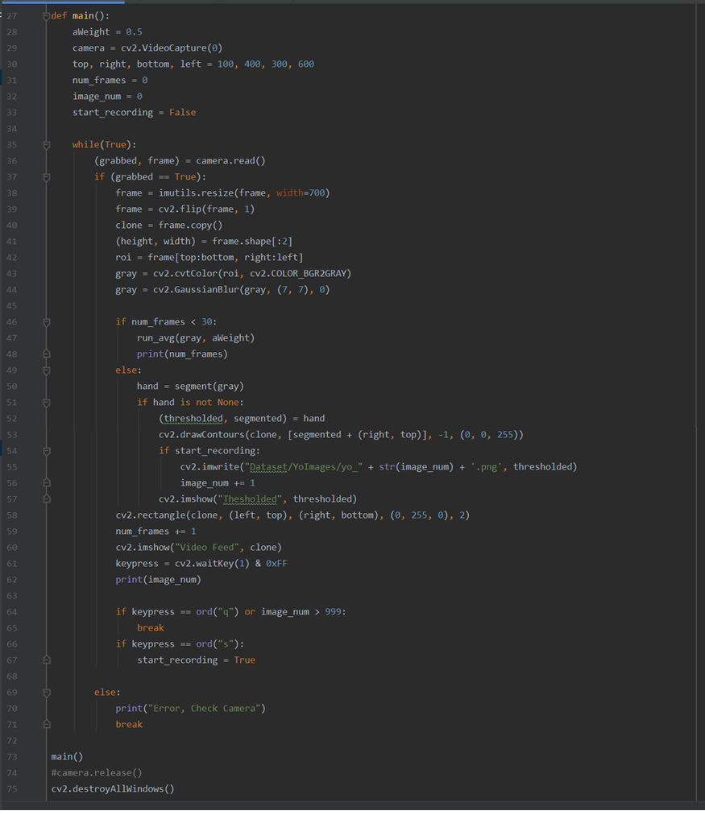 Figure 3.1.2 Code for dataset generation

Two additional functions help in background elimination and detecting the required contour of the image. This helps in reducing the noise in the images and provide better image quality.

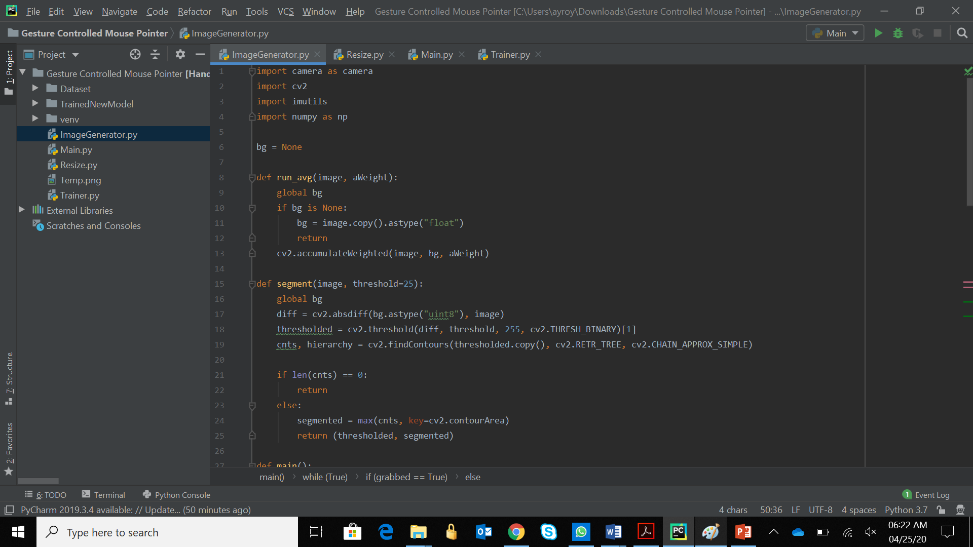Figure 3.1.3 Functions for dataset generation

**3.2 Preprocessing Dataset**

Once the dataset is generated, all the images must be resized to a fixed size for all the computations to take place. Same sized images are required for all the computations to take place. It eases the computation process if the size of the images is known. Every image is converted to 100 x 89 pixels and the previous image is overwritten with the new resized image.

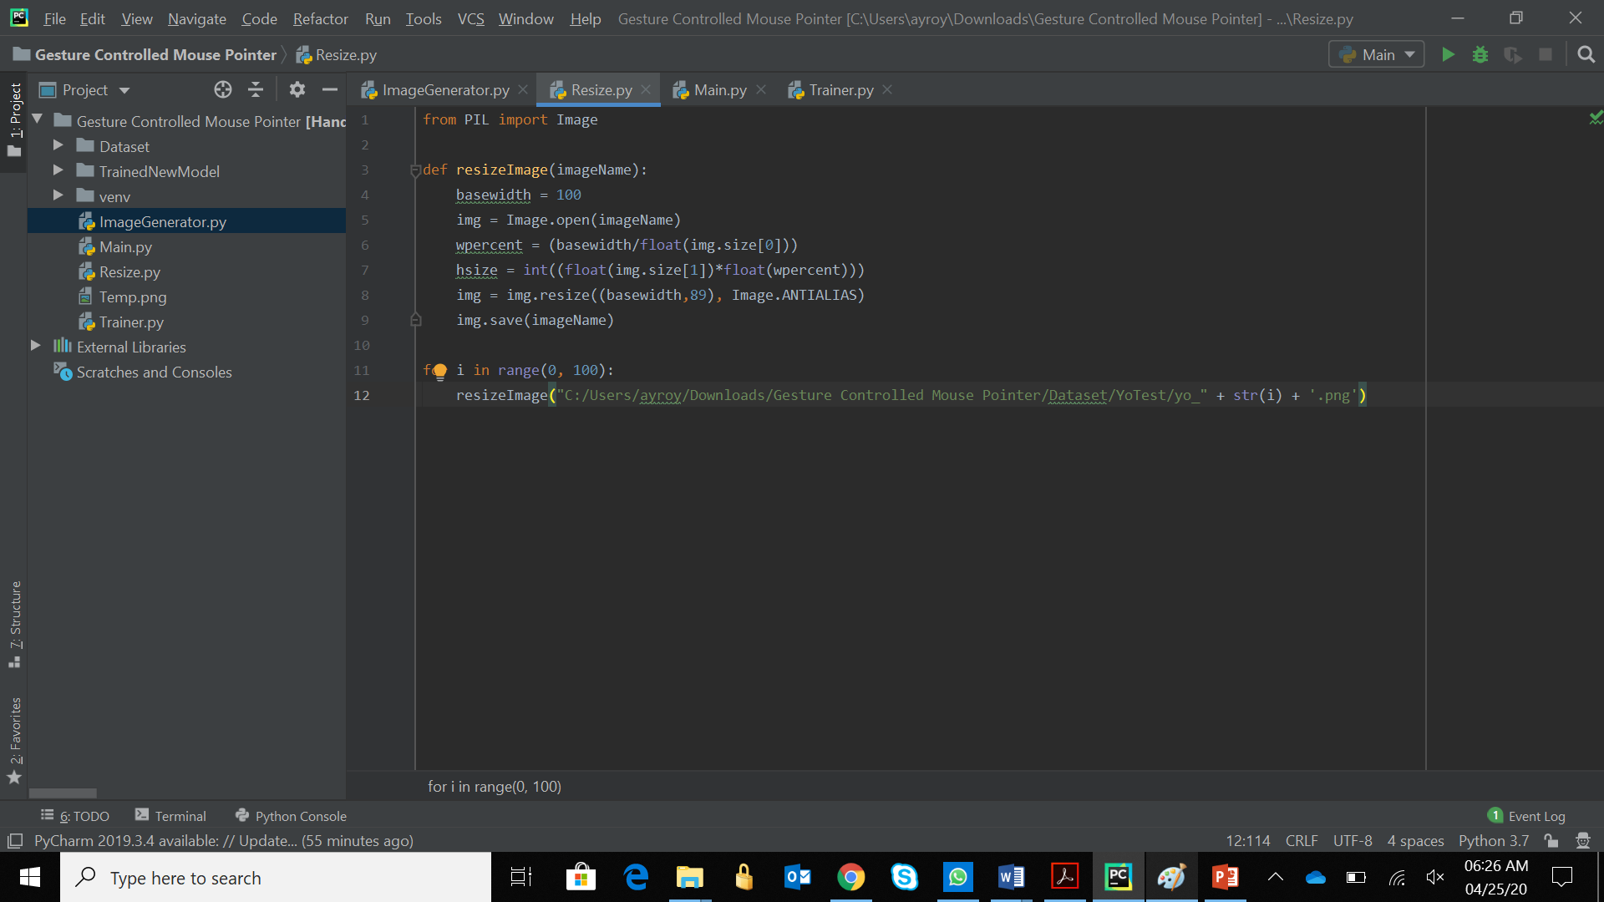Figure 3.2 Code for resizing images

**3.3 Model Training using Neural Network**

In Machine Learning, Deep Neural Networks (DNN) is a supervised learning algorithm where the machine recurrently performs the same task on every element of the sequence of where the output of each task is dependent on every previous calculation. This method learns in a sequence called feature hierarchy. Where the features on the top of the hierarchy are computed by the help of features at the bottom of the hierarchy. DNN’s are formulated of multiple layers. The computations in each layer are hidden hence the layers are termed as “hidden layers “. Epoch is a parameter that determines the number of times the algorithm will work on the entire training dataset. In this case, the Epoch is set to 50 meaning the system will repeat the same process 50 times.

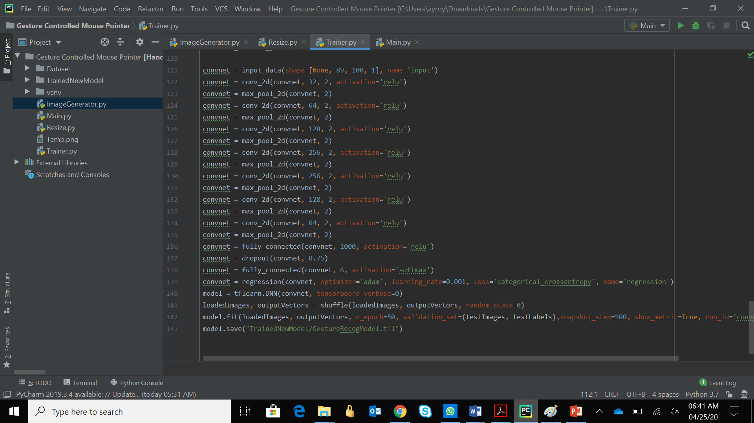Figure 3.3 Code for convolutional neural networks